

Semester One Examination, 2016

Question/Answer Booklet

MATHEMATICS

SOLUTIONS
METHODS
UNIT 3

Section One:

Calculator-free

Student Number: In figures

In words

Your name

Time allowed for this section
Reading time before commencing work: five minutes
Working time for section: fifty minutes

Materials required/recommended for this section
To be provided by the supervisor
This Question/Answer Booklet
Formula Sheet

To be provided by the candidate
Standard items: pens (blue/black preferred), pencils (including coloured), sharpener, correction fluid/tape, eraser, ruler, highlighters

Special items: nil

Important note to candidates
No other items may be taken into the examination room. It is your responsibility to ensure that you do not have any unauthorised notes or other items of a non-personal nature in the examination room. If you have any unauthorised material with you, hand it to the supervisor before reading any further.

Structure of this paper

Section | Number of questions available | Number of questions to be answered | Working  time (minutes) | Marks available | Percentage of exam
Section One:  Calculator-free | 8 | 8 | 50 | 48 | 35
Section Two:  Calculator-assumed | 13 | 13 | 100 | 101 | 65
 |  |  | Total | 149 | 100

Instructions to candidates

- The rules for the conduct of examinations are detailed in the school handbook. Sitting this examination implies that you agree to abide by these rules.

- Write your answers in this Question/Answer Booklet.

- You must be careful to confine your response to the specific question asked and to follow any instructions that are specified to a particular question.

- Spare pages are included at the end of this booklet. They can be used for planning your responses and/or as additional space if required to continue an answer.
- Planning: If you use the spare pages for planning, indicate this clearly at the top of the page.
- Continuing an answer: If you need to use the space to continue an answer, indicate in the original answer space where the answer is continued, i.e. give the page number. Fill in the number of the question that you are continuing to answer at the top of the page.

- Show all your working clearly. Your working should be in sufficient detail to allow your answers to be checked readily and for marks to be awarded for reasoning. Incorrect answers given without supporting reasoning cannot be allocated any marks. For any question or part question worth more than two marks, valid working or justification is required to receive full marks. If you repeat any question, ensure that you cancel the answer you do not wish to have marked.

- It is recommended that you do not use pencil, except in diagrams.

- The Formula Sheet is not to be handed in with your Question/Answer Booklet.

Section One: Calculator-free 35% (48 Marks)
This section has eight (8) questions. Answer all questions. Write your answers in the spaces provided.

Working time for this section is 50 minutes.

Question 1 (5 marks)
Part of the graph of is shown in the diagrams below.

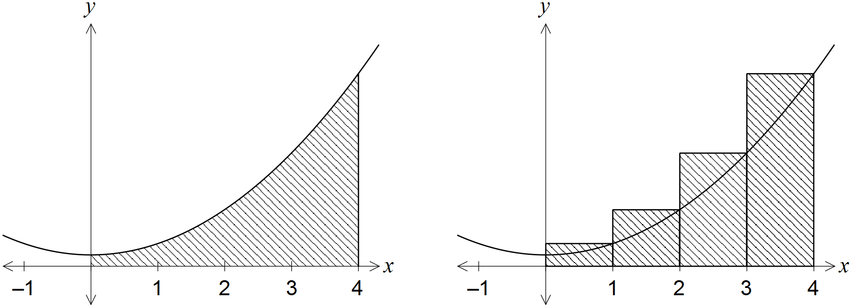

An approximation for the area beneath the curve between and is made using rectangles as shown in the right-hand diagram. Determine the exact amount by which the approximate area exceeds the exact area.
Solution
Specific behaviours
antidifferentiates correctly
evaluates exact area
calculates rectangle heights
evaluates approximate area
calculates difference

Question 2 (9 marks)
(a) Differentiate the following with respect to x, simplifying your answers.

(i) . (2 marks)
Solution
Specific behaviours
adjusts limits of integral
simplifies derivative

(ii) . (3 marks)
Solution
Specific behaviours
uses chain rule for
uses chain rule for
simplifies result

(b) Determine the values of the constants a, b and c, given that when . (4 marks)
Solution
Specific behaviours
uses product rule for first derivative
uses chain rule for first derivative
uses product and chain rules for second derivative
simplifies and states values

Question 3 (6 marks)
A function is such that , where a is a constant and the graph of has a stationary point at (4, 8). Determine .
Solution
Specific behaviours
substitutes and equates to zero
determines value of a
antidifferentiates
determines c
states equation and substitutes
states

Question 4 (7 marks)
Consider the function defined by , .

(a) Determine the coordinates of the stationary point of . (3 marks)
Solution
Specific behaviours
differentiates function
solves
states coordinates of point

(b) Use the second derivative test to determine the nature of the stationary point found in (a). (3 marks)
Solution
Specific behaviours
determines second derivative
shows
states conclusion that point is local minimum

(c) State the global minimum of . (1 mark)
Solution
Specific behaviours
states correct value of global minimum

Question 5 (5 marks)
The area of a segment with central angle in a circle of radius r is given by . Use the increments formula to approximate the increase in area of a segment in a circle of radius 10 cm as the central angle increases from to .

Solution
Specific behaviours
differentiates A wrt
determines for and
determines small change in angle
shows use of increments formula
determines increase in area

Question 6 (5 marks)
(a) Differentiate , simplifying your answer. (3 marks)
Solution
Specific behaviours
uses quotient rule
factors out exponential term
simplifies

(b) Evaluate . (2 marks)
Solution
Specific behaviours
recognises antiderivative will be function from (a)
substitutes limits

Question 7 (6 marks)
The discrete random variable X has the probability distribution shown in the table below.

 | 0 | 1 | 2 | 3

Determine the value of the constant a.

Solution
Specific behaviours
sums distribution to 1
simplifies equation
solves equation for two values of a
checks first value for valid probabilities
checks second value for valid probabilities
states only valid value of a

Question 8 (5 marks)
The area bounded by the curve and the lines , and is exactly square units. Determine the value of the constant k, given that .

Solution
Specific behaviours
writes integral to determine area
antidifferentiates exponential function
substitutes 1 and k and simplifies
equates to area
solves for k

Additional working space

Question number: _________

© 2016 WA Exam Papers. Mercedes College has a non-exclusive licence to copy and communicate this paper for non-commercial, educational use within the school. No other copying, communication or use is permitted without the express written permission of WA Exam Papers.

